Circular-Arc Generator

Definition
# Source: AI Source: Provided by: [Data Path: Persons Table -> ID Column: 1, Name_En Column: Motasem Essam] -> From: [ChatGPT] on [7/25/2026]
A Circular-Arc Generator is a curved-line generator in which a circular arc moves or rotates according to a prescribed geometric rule to produce a surface or a solid.
A circular arc is a continuous portion of a circumference. When it rotates around a fixed axis, it can generate different surfaces of revolution depending on the position and orientation of the axis.
Examples include:
- A semicircular arc rotating about its diameter generates a spherical surface.
- A circular arc rotating about an external coplanar axis can generate a toroidal surface.
- A circular arc rotating about an axis in its plane that intersects the circle can generate part or all of a spherical surface, depending on the arc and axis.
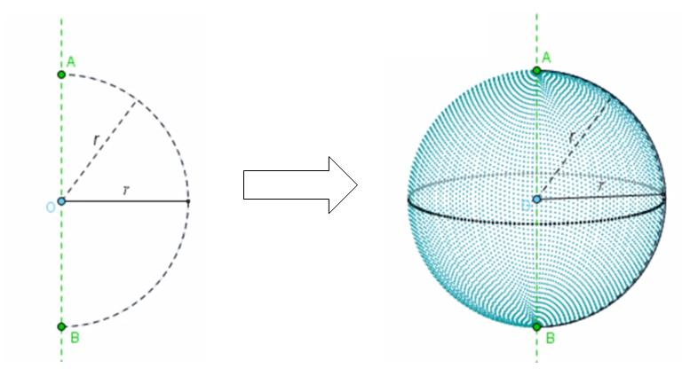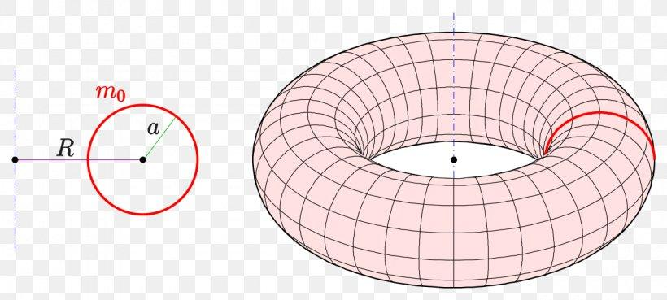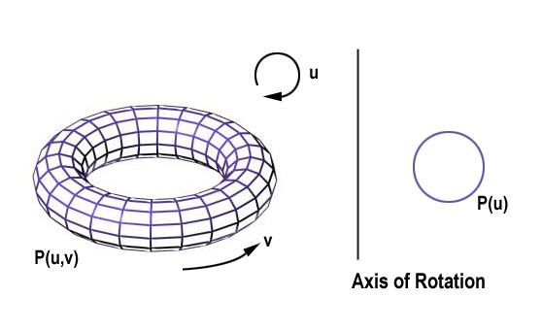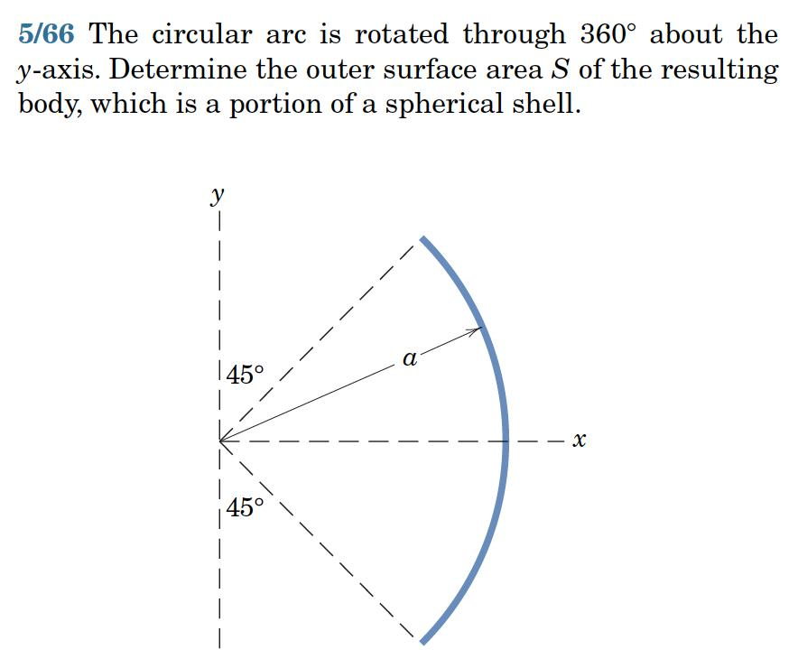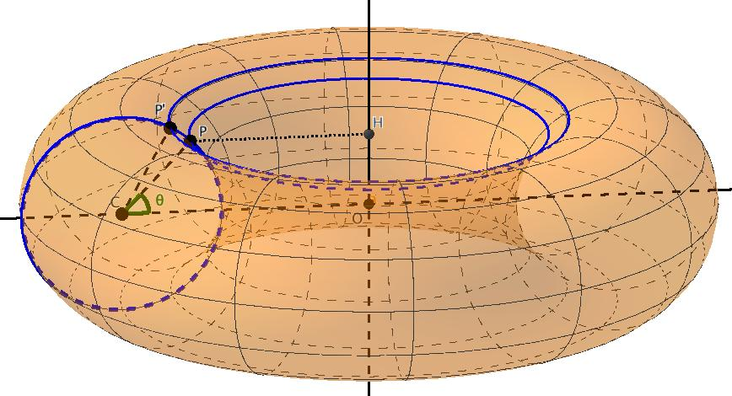

Geometric Structure
# Source: AI Source: Provided by: [Data Path: Persons Table -> ID Column: 1, Name_En Column: Motasem Essam] -> From: [ChatGPT] on [7/25/2026]
A circular-arc generator consists of the following elements:
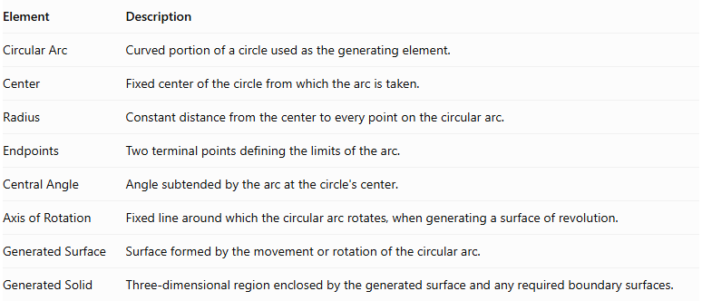
Element | Description
Circular Arc | Curved portion of a circle used as the generating element.
Center | Fixed center of the circle from which the arc is taken.
Radius | Constant distance from the center to every point on the circular arc.
Endpoints | Two terminal points defining the limits of the arc.
Central Angle | Angle subtended by the arc at the circle's center.
Axis of Rotation | Fixed line around which the circular arc rotates, when generating a surface of revolution.
Generated Surface | Surface formed by the movement or rotation of the circular arc.
Generated Solid | Three-dimensional region enclosed by the generated surface and any required boundary surfaces.
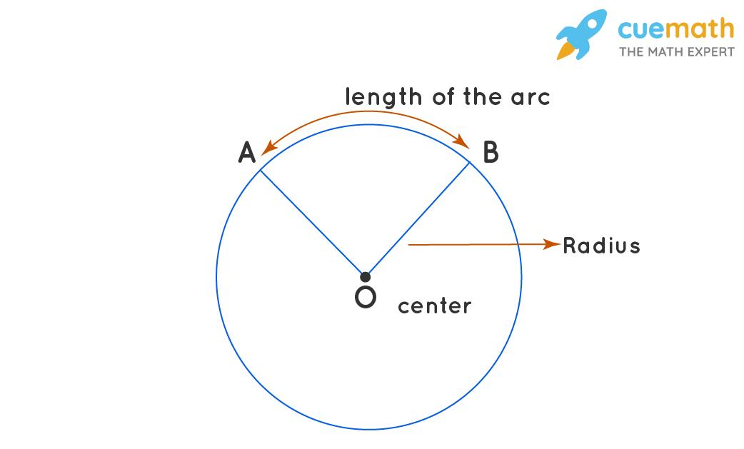

Types of Circular Arcs
# Source: AI Source: Provided by: [Data Path: Persons Table -> ID Column: 1, Name_En Column: Motasem Essam] -> From: [ChatGPT] on [7/25/2026]
Circular-arc generators can be classified according to the angular measure of the arc.

Minor Circular Arc
# Source: AI Source: Provided by: [Data Path: Persons Table -> ID Column: 1, Name_En Column: Motasem Essam] -> From: [ChatGPT] on [7/25/2026]
A Minor Circular Arc is the shorter arc connecting two points on a circle.
Its central angle is less than ${180}^{∘}$.
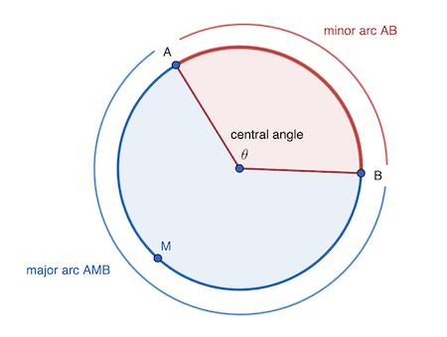

Semicircular Arc
# Source: AI Source: Provided by: [Data Path: Persons Table -> ID Column: 1, Name_En Column: Motasem Essam] -> From: [ChatGPT] on [7/25/2026]
A Semicircular Arc is an arc representing exactly half of a circle.
Its central angle is:
$$θ={180}^{∘}=π\text{ radians}$$
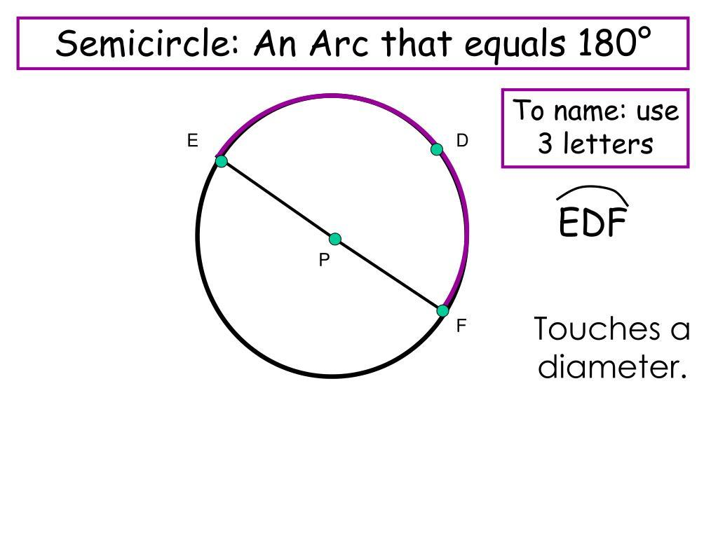

Major Circular Arc
# Source: AI Source: Provided by: [Data Path: Persons Table -> ID Column: 1, Name_En Column: Motasem Essam] -> From: [ChatGPT] on [7/25/2026]
A Major Circular Arc is the longer arc connecting two points on a circle.
Its central angle is greater than ${180}^{∘}$ and less than ${360}^{∘}$.
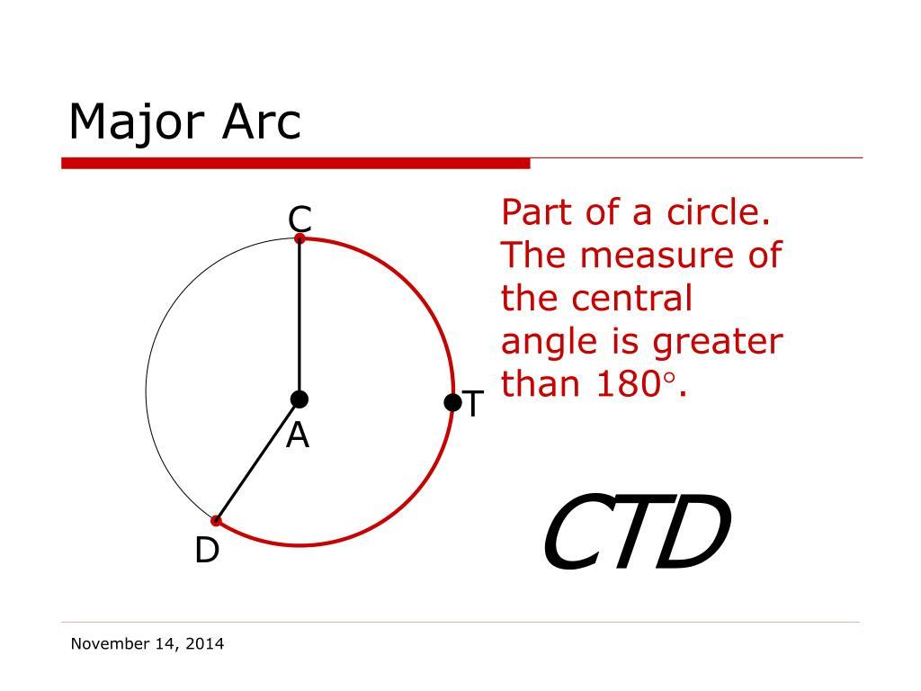

Full Circular Arc (Complete Circumference)
# Source: AI Source: Provided by: [Data Path: Persons Table -> ID Column: 1, Name_En Column: Motasem Essam] -> From: [ChatGPT] on [7/25/2026]
A Full Circular Arc represents the entire circumference of a circle.
Its angular measure is:
$$θ={360}^{∘}=2π\text{ radians}$$
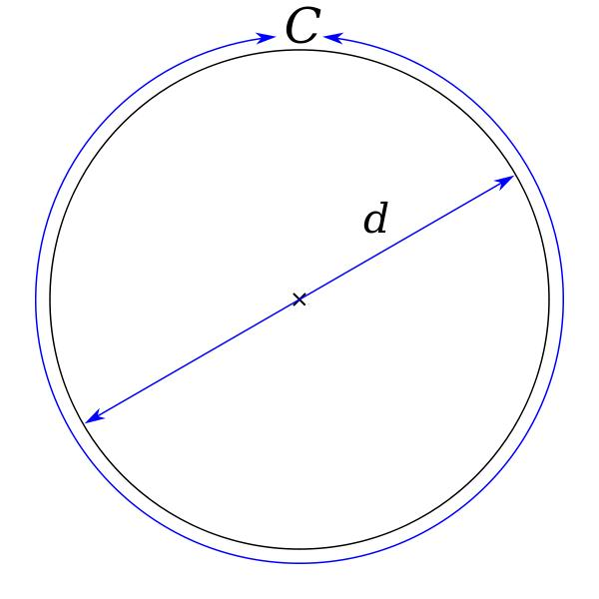

Types According to the Axis of Rotation
# Source: AI Source: Provided by: [Data Path: Persons Table -> ID Column: 1, Name_En Column: Motasem Essam] -> From: [ChatGPT] on [7/25/2026]
When a circular arc rotates around an axis, the resulting surface depends on the relationship between the axis and the circle.

Rotation About a Diameter
# Source: AI Source: Provided by: [Data Path: Persons Table -> ID Column: 1, Name_En Column: Motasem Essam] -> From: [ChatGPT] on [7/25/2026]
When a semicircular arc rotates around its diameter, it generates a Spherical Surface.
The complete semicircular profile sweeps out the entire spherical surface.
Generated surface: Sphere.
Characteristics:
- The axis passes through the center of the circle.
- The axis coincides with the diameter of the semicircular arc.
- Every point on the arc traces a circular path around the axis.
- The resulting surface is spherical.

Rotation About an External Coplanar Axis
# Source: AI Source: Provided by: [Data Path: Persons Table -> ID Column: 1, Name_En Column: Motasem Essam] -> From: [ChatGPT] on [7/25/2026]
When a circular arc rotates around an axis in the same plane as the circle but outside the circle, it can generate a Toroidal Surface.
Generated surface: Torus (or a portion of a toroidal surface if only part of the circle or a partial rotation is used).
Characteristics:
- The axis lies in the plane of the circle.
- The axis does not intersect the circle.
- The circular arc sweeps around the axis.
- A complete circle rotated through ${360}^{∘}$ produces a toroidal surface.

Rotation About an Axis Intersecting the Circle
# Source: AI Source: Provided by: [Data Path: Persons Table -> ID Column: 1, Name_En Column: Motasem Essam] -> From: [ChatGPT] on [7/25/2026]
When a circular arc rotates around an axis in the circle's plane that intersects the circumference or passes through the circle, it can generate spherical portions or more complex rotational surfaces, depending on the arc and axis.
Generated surface: A spherical portion or a related surface of revolution, depending on the configuration.
Characteristics:
- The axis intersects the circle.
- The arc may sweep out only a portion of a spherical surface.
- The resulting shape depends on the arc's angular extent and the axis position.

Mathematical Representation
# Source: AI Source: Provided by: [Data Path: Persons Table -> ID Column: 1, Name_En Column: Motasem Essam] -> From: [ChatGPT] on [7/25/2026]
A circular arc can be represented parametrically in a plane.
For a circle with radius $r$ and center at the origin:
$$x=rcost$$
$$y=rsint$$
where $t$ is restricted to an interval defining the required arc.
For a circular arc rotated around the vertical $z$-axis, with its center located at a distance $R$ from that axis, a parametrization is:
$$\boxed{beginalignedx\&=(R+rcost)cosφ\backslash y\&=(R+rcost)sinφ\backslash z\&=rsintendaligned}$$
Where:
- $r$: Radius of the generating circle.
- $R$: Distance from the generating circle's center to the rotation axis.
- $t$: Parameter along the circular arc.
- $φ$: Rotation angle around the axis.
Important configurations:
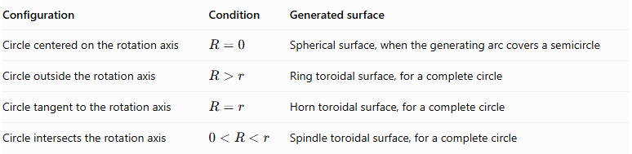
Configuration | Condition | Generated surface
Circle centered on the rotation axis | $$R=0$$ | Spherical surface, when the generating arc covers a semicircle
Circle outside the rotation axis | $$R>r$$ | Ring toroidal surface, for a complete circle
Circle tangent to the rotation axis | $$R=r$$ | Horn toroidal surface, for a complete circle
Circle intersects the rotation axis | $$0<R<r$$ | Spindle toroidal surface, for a complete circle
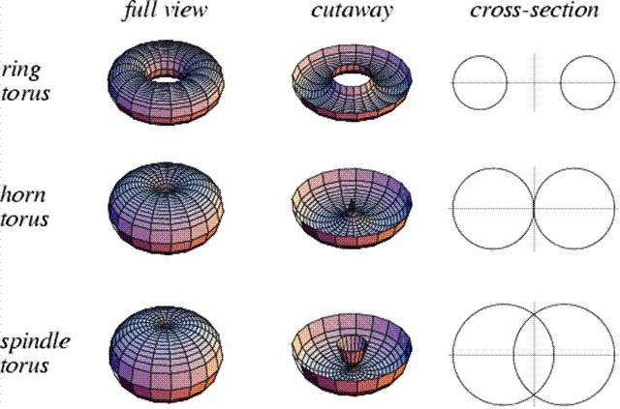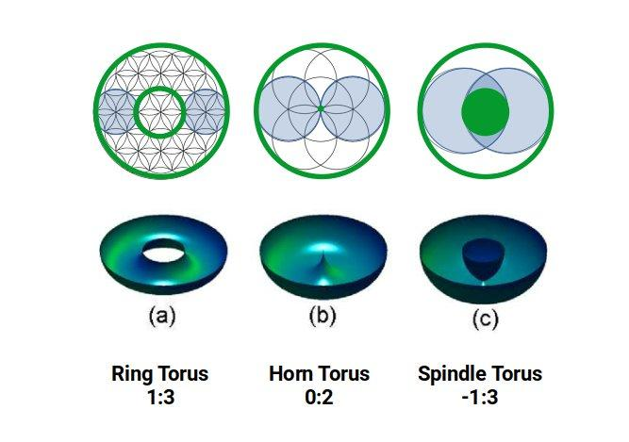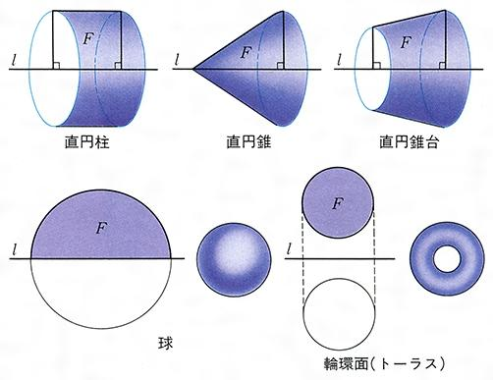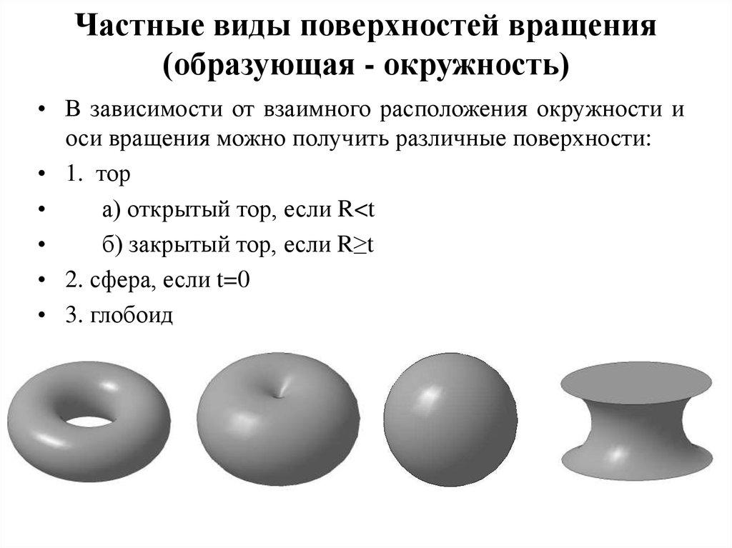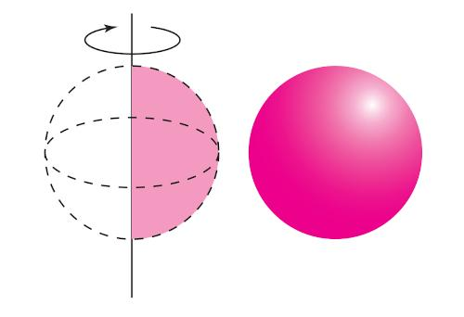

Geometric Measurements of a Circular Arc
# Source: AI Source: Provided by: [Data Path: Persons Table -> ID Column: 1, Name_En Column: Motasem Essam] -> From: [ChatGPT] on [7/25/2026]
For a circular arc with radius $r$ and central angle $θ$, measured in radians:
Arc length:
$$\boxed{s=rθ}$$
Chord length:
$$c=2rsin\left(\frac{θ}{2}\right)$$
Area of the corresponding circular sector:
$$A=\frac{1}{2}r^{2}θ$$
Circumference of the complete circle:
$$C=2πr$$
These measurements describe the generating arc and its associated circular sector, not necessarily the surface area or volume of the generated solid.

Generated Surfaces and Solids
# Source: AI Source: Provided by: [Data Path: Persons Table -> ID Column: 1, Name_En Column: Motasem Essam] -> From: [ChatGPT] on [7/25/2026]
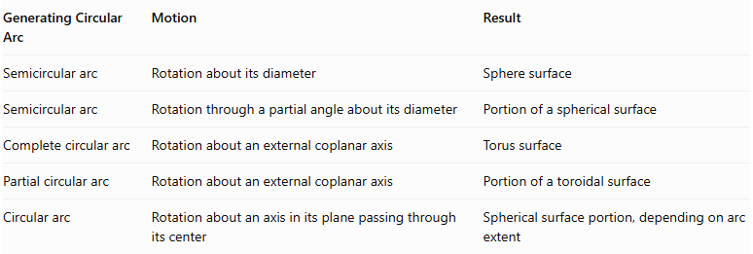
Generating Circular Arc | Motion | Result
Semicircular arc | Rotation about its diameter | Sphere surface
Semicircular arc | Rotation through a partial angle about its diameter | Portion of a spherical surface
Complete circular arc | Rotation about an external coplanar axis | Torus surface
Partial circular arc | Rotation about an external coplanar axis | Portion of a toroidal surface
Circular arc | Rotation about an axis in its plane passing through its center | Spherical surface portion, depending on arc extent
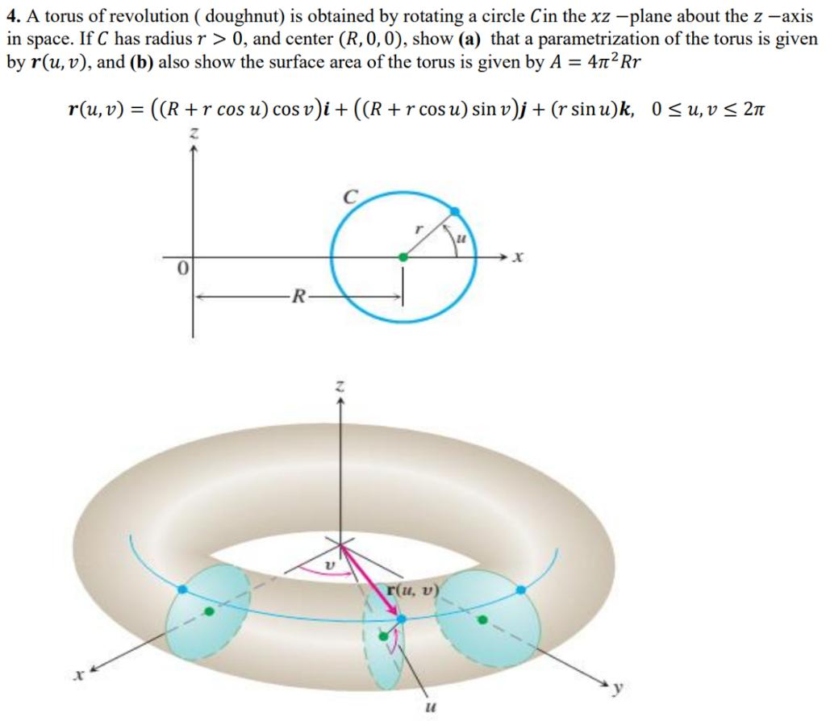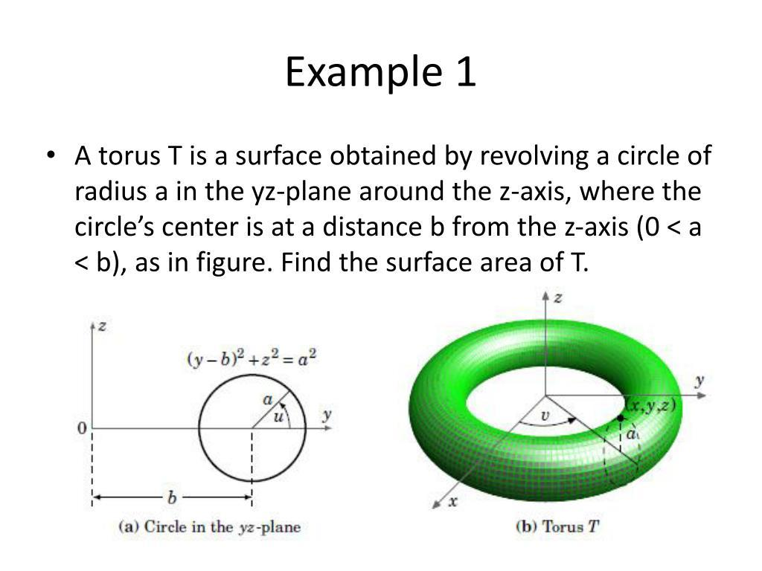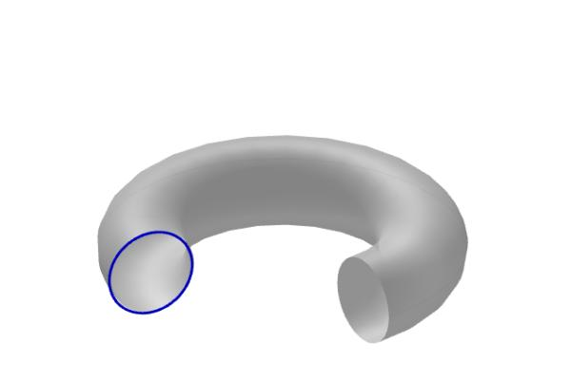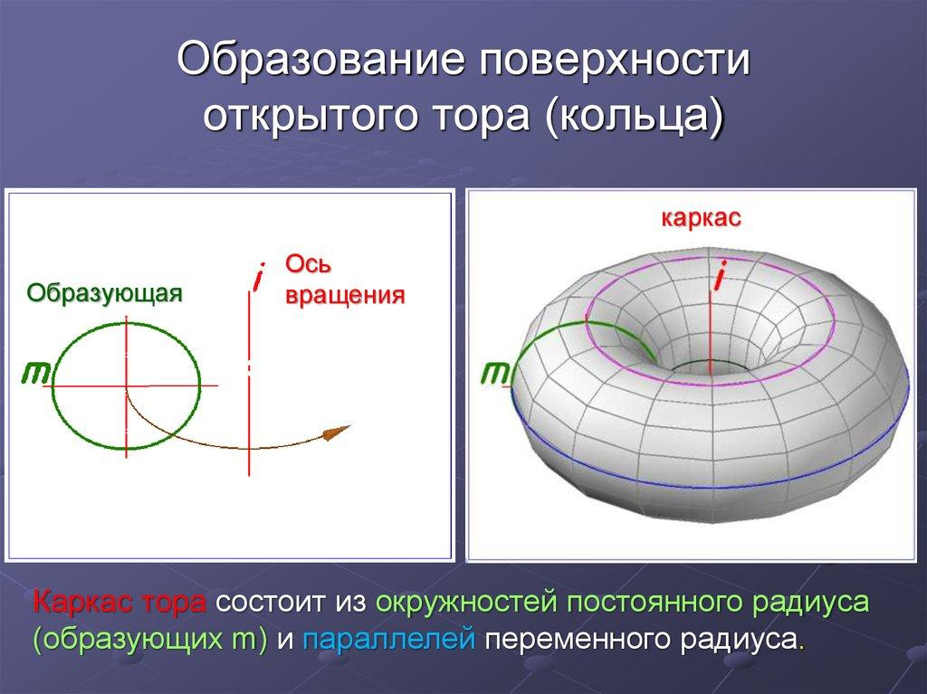
Distinction between a surface and a solid:
- Rotating a circular arc produces a surface of revolution.
- Rotating a filled circular region produces a solid of revolution.
- A semicircular arc rotated about its diameter traces the spherical boundary; the filled semicircular region generates the solid sphere.

Mathematical Properties
# Source: AI Source: Provided by: [Data Path: Persons Table -> ID Column: 1, Name_En Column: Motasem Essam] -> From: [ChatGPT] on [7/25/2026]
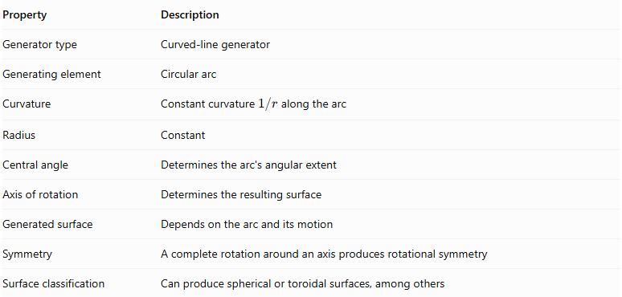
Property | Description
Generator type | Curved-line generator
Generating element | Circular arc
Curvature | Constant curvature $1/r$ along the arc
Radius | Constant
Central angle | Determines the arc's angular extent
Axis of rotation | Determines the resulting surface
Generated surface | Depends on the arc and its motion
Symmetry | A complete rotation around an axis produces rotational symmetry
Surface classification | Can produce spherical or toroidal surfaces, among others

Comparison with Other Curved-Line Generators
# Source: AI Source: Provided by: [Data Path: Persons Table -> ID Column: 1, Name_En Column: Motasem Essam] -> From: [ChatGPT] on [7/25/2026]
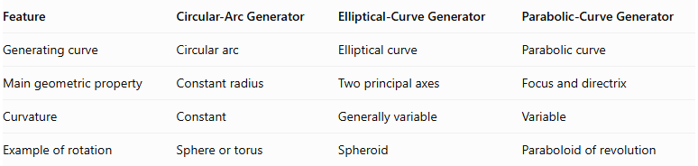
Feature | Circular-Arc Generator | Elliptical-Curve Generator | Parabolic-Curve Generator
Generating curve | Circular arc | Elliptical curve | Parabolic curve
Main geometric property | Constant radius | Two principal axes | Focus and directrix
Curvature | Constant | Generally variable | Variable
Example of rotation | Sphere or torus | Spheroid | Paraboloid of revolution

Main Classification
# Source: AI Source: Provided by: [Data Path: Persons Table -> ID Column: 1, Name_En Column: Motasem Essam] -> From: [ChatGPT] on [7/25/2026]
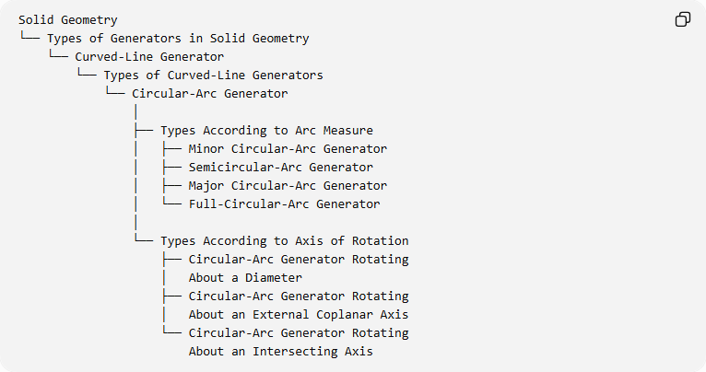
Solid Geometry
└── Types of Generators in Solid Geometry
└── Curved-Line Generator
└── Types of Curved-Line Generators
└── Circular-Arc Generator
│
├── Types According to Arc Measure
│ ├── Minor Circular-Arc Generator
│ ├── Semicircular-Arc Generator
│ ├── Major Circular-Arc Generator
│ └── Full-Circular-Arc Generator
│
└── Types According to Axis of Rotation
├── Circular-Arc Generator Rotating
│ About a Diameter
├── Circular-Arc Generator Rotating
│ About an External Coplanar Axis
└── Circular-Arc Generator Rotating
About an Intersecting Axis

Key Points
# Source: AI Source: Provided by: [Data Path: Persons Table -> ID Column: 1, Name_En Column: Motasem Essam] -> From: [ChatGPT] on [7/25/2026]
- A circular-arc generator uses a portion or the entirety of a circle as its generating curve.
- The circular arc has a constant radius.
- Its central angle determines whether it is a minor arc, semicircular arc, major arc, or complete circle.
- Rotating a semicircular arc about its diameter generates a spherical surface.
- Rotating a complete circle about an external coplanar axis generates a toroidal surface.
- The axis position and the arc's angular extent determine the generated surface.
- A rotating curve generates a surface, whereas a rotating filled region generates a solid.

Conclusion
# Source: AI Source: Provided by: [Data Path: Persons Table -> ID Column: 1, Name_En Column: Motasem Essam] -> From: [ChatGPT] on [7/25/2026]
The Circular-Arc Generator is a type of curved-line generator that uses a circular arc to produce geometric surfaces through movement or rotation.
It is particularly important in generating spherical and toroidal surfaces and provides a foundation for understanding more complex curved-line generators.

